

Luo brings this up in the intro as part of the story for local Godement-Jacquet theory but never seems to reference it again. Why distinguish between this and the more conventional choice of Schwartz functions?

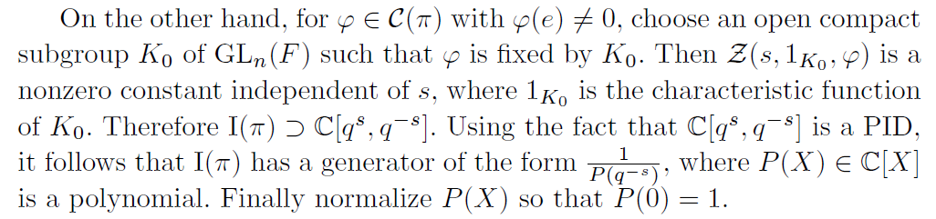

I don’t know what Luo means by saying that \phi is fixed by K_0. If I go with the interpretation that \phi is constant on K_0 then I get that Z(s,1_{K_0},\phi) is not independent of s. I also don’t see why this zeta function being independent of s implies that I(\pi) contains C[q^s,q^{-s}]. If I write things out then I get

Z(s,1_{K_0},\phi) = \int_{K_0} \phi(g)|\det g|^{s+(n-1)/2} dg.

Does this have to do specifically with the integral of the stuff excluding \phi(g)?

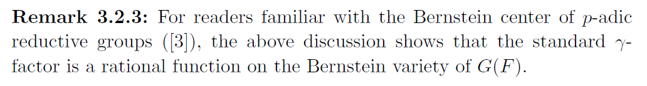

Is there more that I should know about this Bernstein variety? In what sense does this play the same role as \eta did for Tate’s thesis?

Let f be a Schwartz function on M_n(F) and \phi a matrix coefficient associated to \pi (our irreducible admissible representation of GL_n(F)). The shifted zeta function \tilde{Z}(s,f,\phi) can be written as

\int_{GL_n(F)} f(g)\phi(g)|\det g|^s dg.

This can be rewritten as Z_0 := Z(T(s,f,\phi),\omega_{\pi}|\cdot|^{ns}) in the sense of Tate’s thesis, for \omega_{\pi} the central character of \pi and T(s,f,\phi) the Schwartz function on F given by

T(s,f,\phi)(a) = \int_K f(ak)\phi(k)|\det k|^s dk

where K = GL_n(\O_F) and dk is a suitable Haar measure such that dk(K)=1. What exactly does Tate’s thesis tell us about Z_0 (I see how to get absolute convergence for Re(s) sufficiently large)? For example, how do the results on analytic and meromorphic continuation tell us that Z_0 is a rational function in C(q^{-s})? What role explicitly do the \gamma-, \epsilon-, and Euler factors of Tate’s thesis play here? I see what to do in the case that \pi is spherical but not more generally… Can I do more with the FE in Tate’s thesis than Luo does?

Where do I actually get that I(\pi) is a fractional ideal? I know in the case of Tate’s thesis that we proved the FE for a specific Schwartz function and then used Tate’s integral exchange trick to deduce the FE in general. I presume we get what we want from the following result (though I would appreciate having things spelled out more clearly).

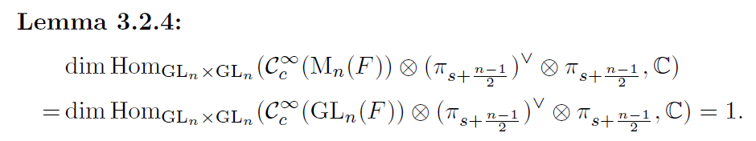

The reason why we are considering these Hom spaces is that the local zeta integrals can be seen as giving a linear functional in



Here I assume \pi_{s+(n-1)/2} just means a twist of \pi by the appropriate power of |\det|. Certainly the local zeta integrals Z(s,f,\phi) can be used to define an endomorphism of V (the vector space of \pi), possibly once we take Re(s) sufficiently large. I see how the Schwartz functions are a (smooth) module over GL_n(F)\times GL_n(F). What is the action on the other tensor product factors?

Let’s get into the proof of the lemma. To start, Luo claims

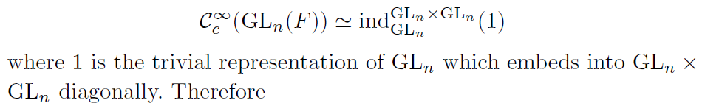

Here, ind denotes compact induction. I don’t understand how the induction makes sense. Why should GL_n embedded diagonally in GL_n\times GL_n be a parabolic subgroup? It doesn’t seem to me like it contains a Borel subgroup (assuming I’m right that the Borels in GL_n\times \GL_n are pairwise products of Borels). We then get

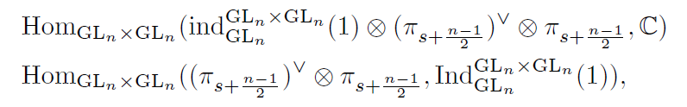

So far so good. Luo then says we can apply Frobenius reciprocity to get



I assume this works because the Jacquet module of the trivial representation is C and so tensoring up with this on the LHS does nothing. We then use Schur’s lemma to deduce that this Hom space has dim 1, so the original Hom space with GL_n(F) has dim 1 as well. At this point we’re halfway done since we still need to show



is equal to 1. Luo then says

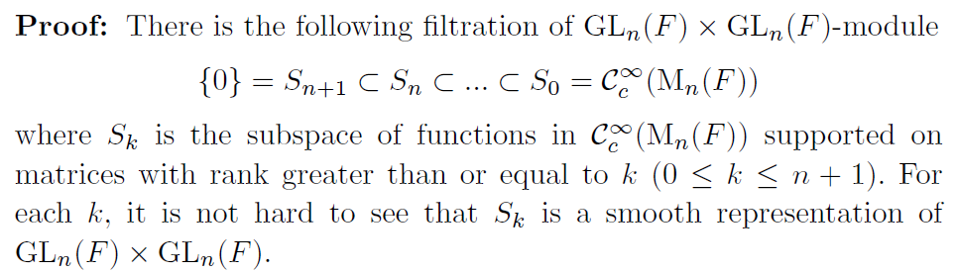

This all makes sense to me. What he says next does not.

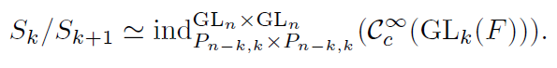

The LHS can be roughly understood as Schwartz functions supported on matrices of rank exactly k. I can vaguely see why we might have an isomorphism like this but I’m not sure exactly what the map looks like. Maybe some inspiration comes from this result

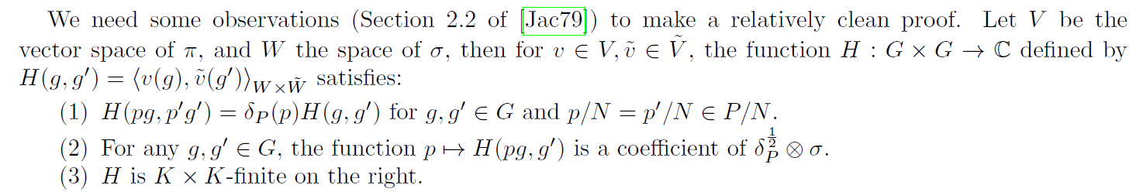

lifted from Wang’s paper *Zeta Integrals and Principal L-Functions of General Linear Groups*. For context on how these things are defined, we have

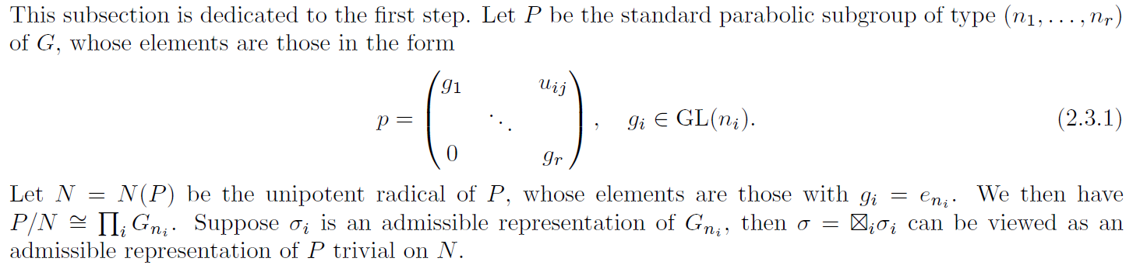

We obtain \pi by applying \Ind_P^G to \sigma. Once we have the isomorphism S_k/S_{k+1}, I can see why the Hom space associated to each such quotient vanishes. In what way is the entire Hom space for M_n(F) built from these quotients? Presumably it decomposes as a direct sum so that we can ignore the terms that vanish.

Once all of this is done, Luo then claims

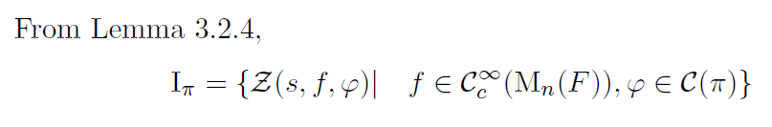

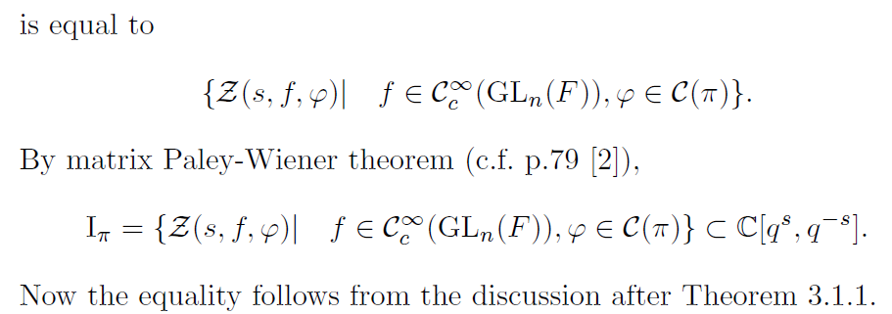

I don’t see why the lemma lets us bridge the first gap. I’ve already expressed my difficulties with discussion cited here following Theorem 3.1.1. How am I supposed to think this matrix Paley-Wiener theorem (it’s not something I’m familiar with)? It’s also not clear what connection the statement in the reference (pg. 79 of [2]) has to this claim.

All of this seems rather different to the approach taken in the paper of Wang mentioned earlier. I’d like to understand how to reconcile the two approaches, especially since Wang draws from original work of Godement and Jacquet.